**Install ELK + Fleet Server**

1. Download and run the ELK installation.
   1. Wget <https://raw.githubusercontent.com/AnthonyH26/Elastic-With-Fleet/main/install%20elk.sh>
   2. Chmod +x ‘install elk.sh’
   3. Sudo ./install\ elk.sh
2. Select Appropiate TLS settings (IP/DNS/both)
3. Note down password for elastic user
4. Log in and go to management > fleet
5. Go to settings
   1. Modify 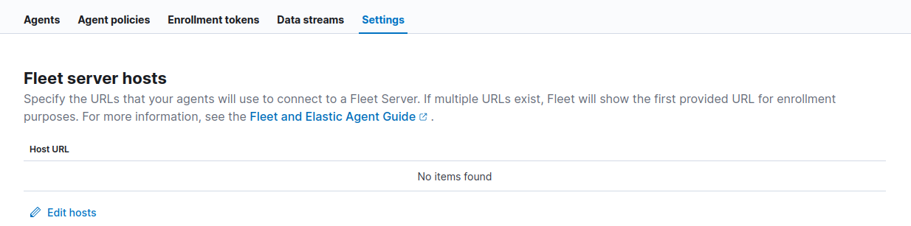

To be the host you run Fleet server on (Include the port (8220 by default) and HTTPS)

* 1. Modify Outputs section to include the domain/IP on your elasticsearch Cert generated in step 2
  2. Cat the elasticsearch CA and view <https://github.com/AnthonyH26/Elastic-With-Fleet/blob/main/Examples/Example_ssl.yml> and replace the CA contents in the file before adding it to the UI (ENSURE INDENTATION IS CORRECT)  
     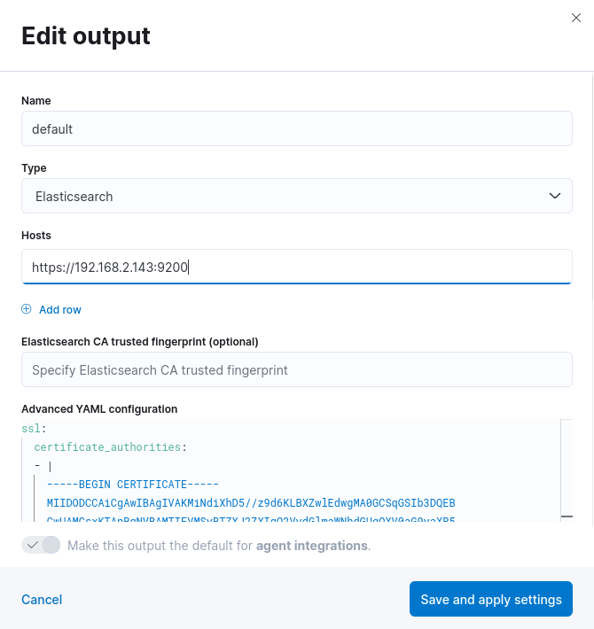

1. Choose Advanced Settings, name the server policy and create it
2. Choose Production
3. Add host
4. Generate Service token and save it somewhere safe
5. Wget <https://raw.githubusercontent.com/AnthonyH26/Elastic-With-Fleet/main/fleet%20server.sh>
6. Chmod +x ‘fleet server.sh’
7. Run the script - ./fleet\ server.sh ( ENSURE IP/DOMAINS MATCH IN THE WEB UI AS ON THE CERTS )
8. You should see  
   